Spring REST using Spring Boot 3
Name: NALLANI LOKAKALYAN
Registered Mail: 2300030853cseh1@gmail.com

Hands on 1
Create a Spring Web Project using Maven:

Spring Learn Application.java:
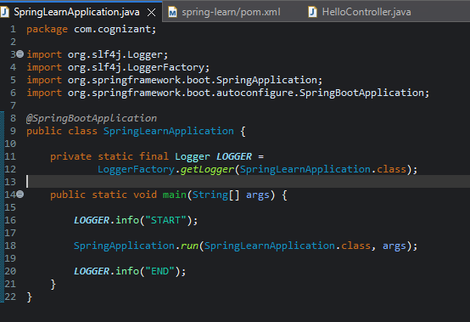

HelloController.java:
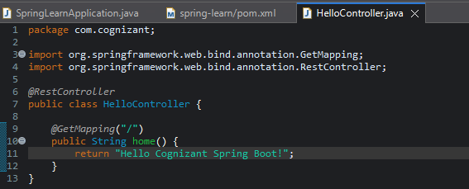
Pom.xml:
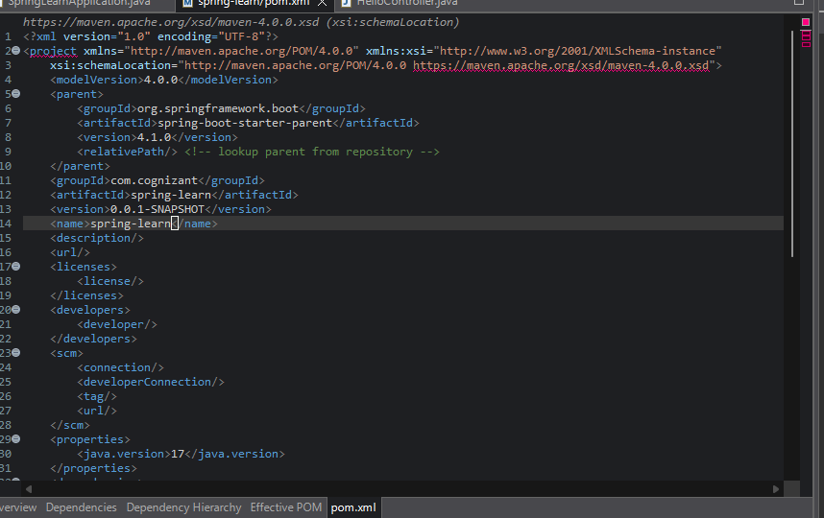
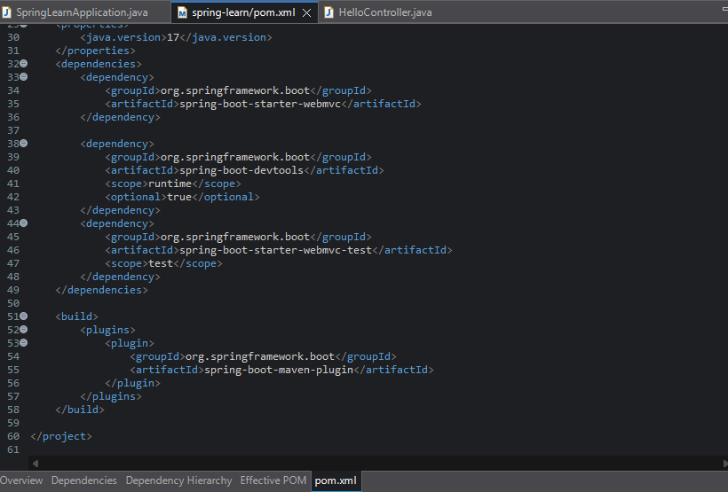

Output:
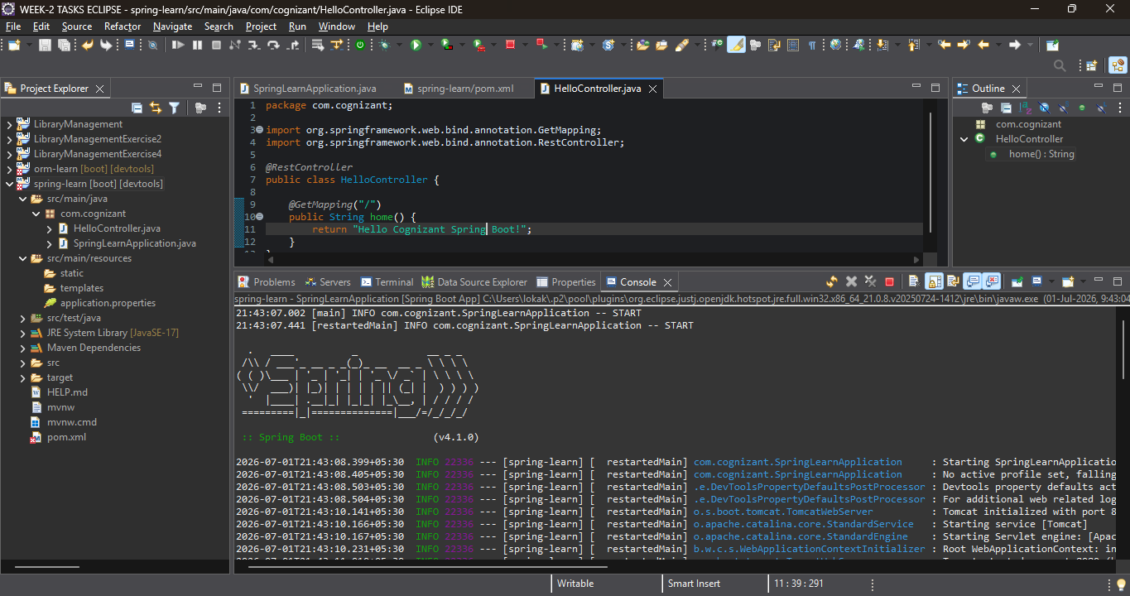
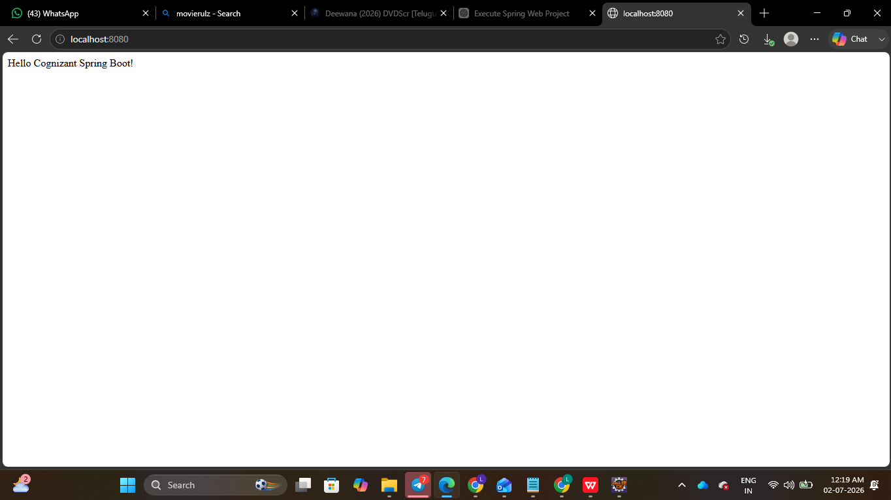

Hands on 2
Spring Core – Load SimpleDateFormat from Spring Configuration XML:
Spring Learn Handson2 Application.java:
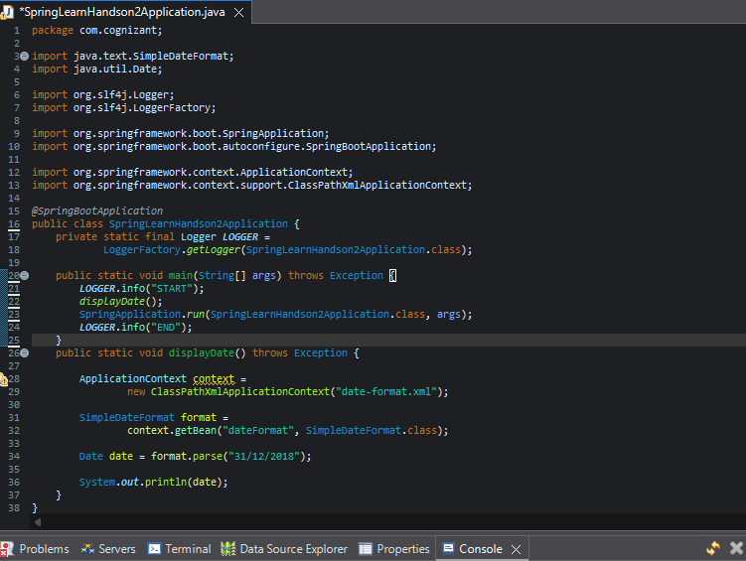
Pom.xml:
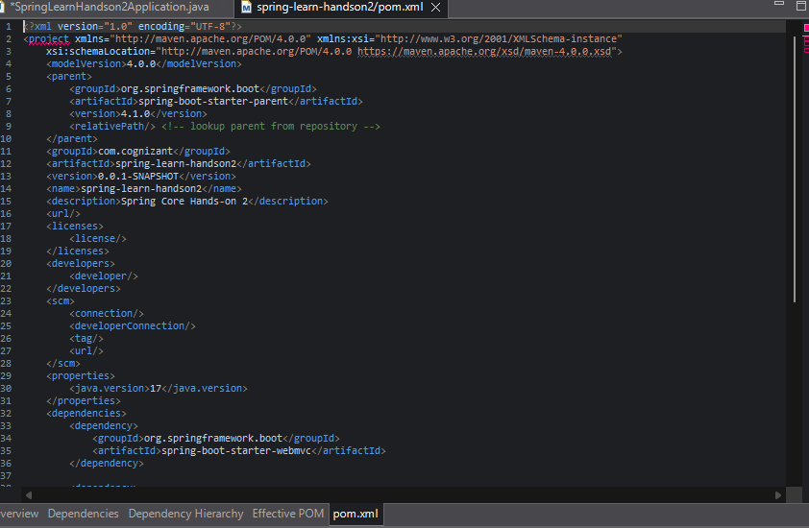
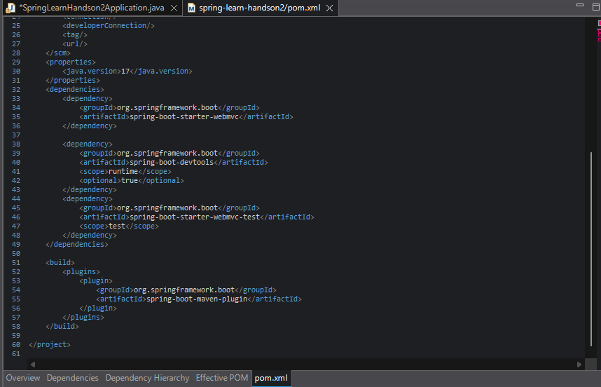

Output:
